FFUF TOOL – COMPREHENSIVE TECHNICAL DOCUMENTATION
A High-Performance Web Fuzzing and Enumeration Tool for Ethical Hacking & Penetration Testing

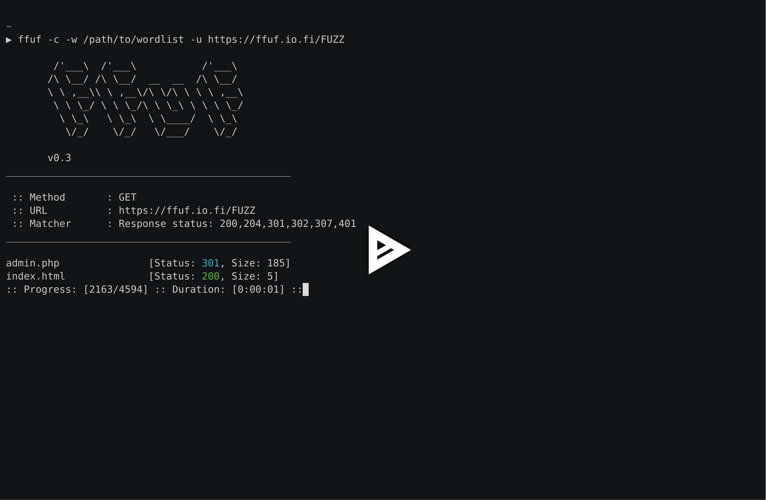
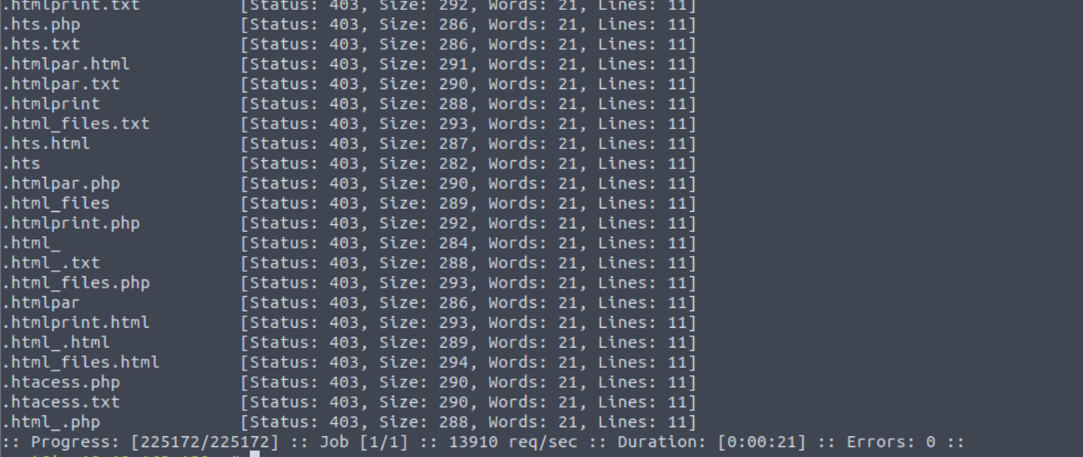
4

ABSTRACT
Modern web applications expose complex attack surfaces through directories, files, parameters, APIs, and virtual hosts. Traditional directory brute-forcing tools are often insufficient for discovering deeply hidden or dynamically generated resources. This document presents a comprehensive technical study of FFUF (Fuzz Faster U Fool), a high-performance web fuzzing tool widely used in ethical hacking and penetration testing. The report explains the theoretical background, internal working mechanism, command usage, practical case studies, advantages, limitations, and defensive considerations. The objective of this documentation is to provide an academic and practical understanding of FFUF suitable for cybersecurity coursework, lab records, interviews, and professional security assessments.

1. INTRODUCTION
Web applications today rely heavily on dynamic routing, APIs, and parameter-driven logic. Sensitive functionality may be hidden behind undocumented endpoints, parameters, headers, or file paths. Attackers frequently exploit this by performing fuzzing, a technique that systematically tests large numbers of inputs to identify valid resources or unexpected behavior.
FFUF is a modern fuzzing tool designed to discover such hidden components at very high speed. Unlike traditional directory brute-force tools, FFUF can fuzz URLs, parameters, headers, cookies, POST data, and virtual hosts, making it extremely versatile.

2. OBJECTIVE OF THE STUDY
The objectives of this documentation are:
- To understand web fuzzing and advanced enumeration techniques
- To study the working mechanism of FFUF
- To analyze FFUF command usage and options
- To demonstrate real-world usage through practical case studies
- To evaluate strengths, limitations, and security implications
- To provide exam-ready and submission-ready content

3. BACKGROUND: WEB FUZZING IN CYBER SECURITY
Web fuzzing is part of the Scanning & Enumeration phase of penetration testing. It focuses on discovering:
- Hidden directories and files
- Undocumented API endpoints
- Hidden parameters and inputs
- Authentication bypass vectors
- Virtual hosts and misconfigurations
Unlike vulnerability scanners, fuzzing tools focus on input discovery, which often leads to high-impact vulnerabilities when combined with logic flaws or access control issues.
FFUF automates fuzzing with high performance and precision.

4. OVERVIEW OF FFUF TOOL
FFUF is an open-source web fuzzing tool written in Go (Golang), providing excellent speed and concurrency. It is included by default in Kali Linux and is widely used in bug bounty programs, CTFs, and professional penetration tests.
Key features of FFUF include:
- Multi-threaded fuzzing engine
- Flexible fuzzing locations (URL, params, headers, POST data)
- Smart filtering based on status codes, size, and words
- JSON and text output formats
FFUF does not exploit vulnerabilities directly; instead, it discovers inputs and resources that can later be tested for vulnerabilities.

5. ARCHITECTURE AND WORKING MECHANISM
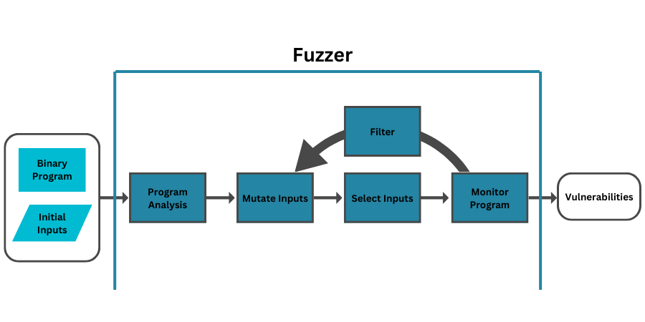
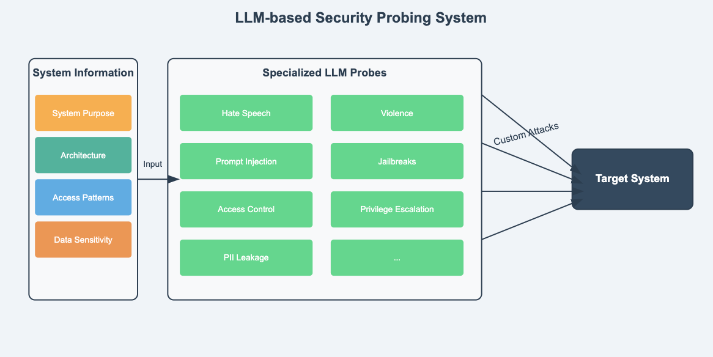
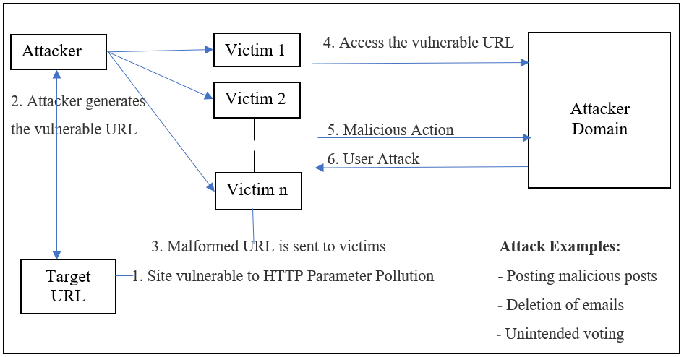
FFUF operates using a highly optimized fuzzing workflow:
- Target Definition
A URL or request template containing the FUZZ keyword is defined.
- Wordlist Injection
Each word from the wordlist replaces the FUZZ placeholder.
- Concurrent Request Engine
Requests are sent in parallel using goroutines.
- Response Analysis
Responses are analyzed based on status code, size, word count, or regex.
- Result Filtering & Reporting
Valid or interesting responses are displayed and saved.
This architecture allows FFUF to fuzz thousands of requests per second.

6. INSTALLATION AND ENVIRONMENT
FFUF is pre-installed in Kali Linux.
To verify installation:
ffuf -h
FFUF requires no special privileges and works with HTTP and HTTPS targets.

7. COMMAND USAGE AND ANALYSIS
7.1 Basic Directory Fuzzing
ffuf -u http://example.com/FUZZ -w /usr/share/wordlists/dirb/common.txt
Discovers hidden directories and files.

7.2 File Extension Fuzzing
ffuf -u http://example.com/FUZZ -w wordlist.txt -e .php,.html,.txt
Tests multiple file extensions.

7.3 Parameter Fuzzing
ffuf -u "http://example.com/index.php?param=FUZZ" -w params.txt
Discovers hidden or undocumented parameters.

7.4 POST Data Fuzzing
ffuf -u http://example.com/login -X POST -d "username=admin&password=FUZZ" -w passwords.txt
Used for logic testing and authentication analysis.

7.5 Filter Responses by Size
ffuf -u http://example.com/FUZZ -w wordlist.txt -fs 4242
Removes false positives with identical response sizes.

7.6 Save Output to File
ffuf -u http://example.com/FUZZ -w wordlist.txt -o ffuf_results.json

8. PRACTICAL CASE STUDY
Scenario
A penetration tester performs advanced web enumeration on a target application.
Execution
ffuf -u http://192.168.146.131/FUZZ -w /usr/share/wordlists/dirb/common.txt -fs 403
Observations
- Discovered /admin/ directory
- Found /api/ endpoint
- Identified hidden /debug/ path
Impact Analysis
These findings revealed sensitive application functionality and enabled further attacks such as authentication bypass, API abuse, and information disclosure.

9. ADVANTAGES OF FFUF
- Extremely fast and efficient
- Highly flexible fuzzing capabilities
- Excellent filtering and output control
- Suitable for modern web applications and APIs
- Widely used in bug bounty programs

10. LIMITATIONS OF FFUF
- Requires understanding of fuzzing logic
- Can generate high traffic
- Dependent on quality of wordlists
- No built-in crawling

11. FFUF VS OTHER WEB ENUMERATION TOOLS
Tool | Speed | Flexibility | Best Use Case
FFUF | Very High | Very High | Advanced fuzzing
Dirsearch | Medium–High | Medium | Recursive enumeration
Gobuster | High | Medium | Fast discovery
DIRB | Medium | Low | Basics & learning
FFUF is best suited for advanced and precise web fuzzing.

12. SECURITY AND DEFENSIVE CONSIDERATIONS
Organizations can defend against FFUF-style attacks by:
- Implementing rate limiting
- Using Web Application Firewalls (WAF)
- Enforcing strict access controls
- Monitoring abnormal request patterns

13. LEGAL AND ETHICAL CONSIDERATIONS
FFUF must only be used on web applications where explicit authorization has been granted. Unauthorized fuzzing may violate cyber laws and institutional policies.

14. CONCLUSION
FFUF is a powerful and modern web fuzzing tool that goes beyond traditional directory brute forcing. Its flexibility, speed, and precision make it an essential tool for discovering hidden attack surfaces in contemporary web applications. Mastery of FFUF equips cybersecurity students and professionals with advanced reconnaissance and enumeration skills.

15. REFERENCES
- Kali Linux Documentation
- OWASP Web Security Testing Guide
- FFUF GitHub Repository

